Practice quiz 9(已完成)

**1.** Please indicate whether the following statement is true or false.

“The more data we get, the more accurately we can estimate the mean of the observations in the data. Regression models based on mean squared error are therefore likely to be strong synthesis models on big datasets.”

* True
* False

**2.**Gustav is building a robot clone of himself that can answer questions when he's out of office. Right now he's designing the system for interactive question answering in the robot.

His system uses a microphone to listen to spoken user input, which it then converts to text. Afterwards it applies natural language understanding to make sense of the user's intent. Based on the user's intent, the system creates a text sentence in response, which it then converts to an audio signal. That signal is then played out to the user using a speaker in the robot.

Please indicate which steps that are considered data-generation tasks:

* 1. Converting speech audio to text
* 2. Converting text to user intent
* 3. Converting user intent to a text response
* 4. Converting text to speech audio

**3.**Please indicate for which of the following situations it makes sense to reduce the temperature when generating output from the model.

* A state-of-the-art deterministic regression model.
* A state-of-the-art probabilistic mixture model.
* A state-of-the-art generative adversarial network.

**4.**Let x be a random variable representing observations and let y be a random variable representing their corresponding labels. These two random variables are therefore dependent.

Indicate which ones of the following models can be used for conditional synthesis.

* A conditional distribution P y|x
* A conditional distribution P x|y
* A regression model x^ = f(y,θ)
* A classifier l x^ = g(y,θ)

**5.**Is the following statement true or false?

Objective evaluation measures, like the likelihood, are a better basis for selecting which model to use for a real-world application than subjective measures, because the human participants in subjective measures are always biased to some extent.

* True
* False

**6.**Please indicate whether the following statement is true or false:

“Synthesis is only used for generating things that humans look at and/or listen to.”

* True
* False

**7**.Please categorise the following evaluation metrics.

Objective measures



Subjective measures



**8.**You are evaluating the performance of your new image-synthesis system by showing output images to the other students in your class and asking them to rate the image quality on a scale from 1 to 5. What type of evaluation is this?

* Subjective evaluation
* Objective evaluation
* Neither

**9.**Dalí Jr. has developed a system that generates pictures of oil paintings based on a text prompt y. He wants to see if the new system generates paintings that more accurately depict the input text, compared to a pre-existing system called Text2Oil.

To find out which system gives the more accurate paintings, Dalí Jr. will conduct a pairwise subjective evaluation. He will show the participants several pairs of paintings, each painting together with its corresponding input prompt y. For each pair of paintings, he asks the participant which painting in the pair that is the more accurate rendition of its associated prompt. One painting in every pair will have been generated by Text2Oil and the other by the new system.

To properly explore how the two systems behave, Dalí Jr. will use a big set {y}of different test prompts in the evaluation, spanning a wide range of complexities. Some prompts are very easy to draw correctly (y= “A blank canvas”), whereas others are very hard to get right (

“The Swedish prime minister riding a horse with exactly nine legs”).

It is important to Dalí Jr. that his evaluation reliably identifies which system gives more accurate paintings. Which of the following two statements is correct?

* Because of the great variation, it is most important to control for the effect of y in the evaluation. Therefore the two paintings in each pair should be based on *the same* input prompt y.
* Because of the great variation, it is most important to cover as many different y-values as possible. Therefore the two paintings in each pair should be based on *different* input prompts y.

**10.**You are evaluating the performance of your new image-synthesis system by showing output images to the other students in your class and computing how often they think that the images are real. What type of evaluation is this?

* Subjective evaluation
* Objective evaluation
* Neither

**11.**Please indicate whether the following statement is true or false:

“The output of a synthesis system is always a continuous random variable. If the output is a discrete random variable, we are performing classification, not synthesis.”

* True
* False

**12**.Let px|y(x|y) be an accurate model of the true conditional density function of x, and let qx|y(x|y) be a weak model of the same (for example a multivariate Gaussian). You want to create synthetic examples x^(y) that are as convincing as possible to human observers, for given inputs y.

Please rank the following output-generation strategies from most to least likely to be convincing:

Most convincing

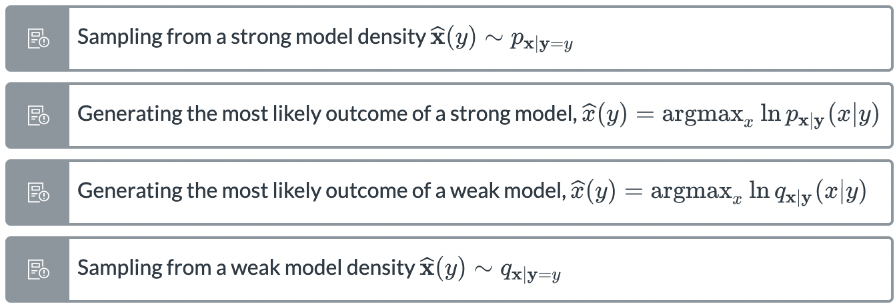

Least convincing

**13.**Is the following statement true or false?

One benefit of generative adversarial networks is that they are very easy to train thanks to the *reduced sampling temperature* trick.

* True
* False

**14.** Indicate which of the below are valid reasons for using objective metrics instead of subjective metrics when tuning a text-to-speech system.

* Objective metrics are usually cheaper to obtain
* Objective metrics more accurately reflect what is important in applications
* Objective metrics usually allow us to iterate faster
* Subjective metrics are hard to compare since they aren't numerical

/////////////////////

1. Is the following statement true or false?

Objective evaluation measures are only used during the development (training) of a synthesis model

–false

3. The *reduced sampling temperature* trick is widely used for improving the quality of the synthesised data when using (deterministic) regression models.

–false

6. Indicate which of the below are valid reasons for using subjective metrics instead of objective metrics when evaluating an image synthesis model.

1. Subjective metrics more accurately reflect what is important in applications

7. You are evaluating the performance of your new image-synthesis system by computing its FID score and comparing it to the FID scores of other synthesis systems. What type of evaluation is this?

1. Objective evaluation

8. In order to generate new data with a synthesis model, we must always provide some sort of conditioning y. —-false

